Temperature show in LCD in Adriano Uno:

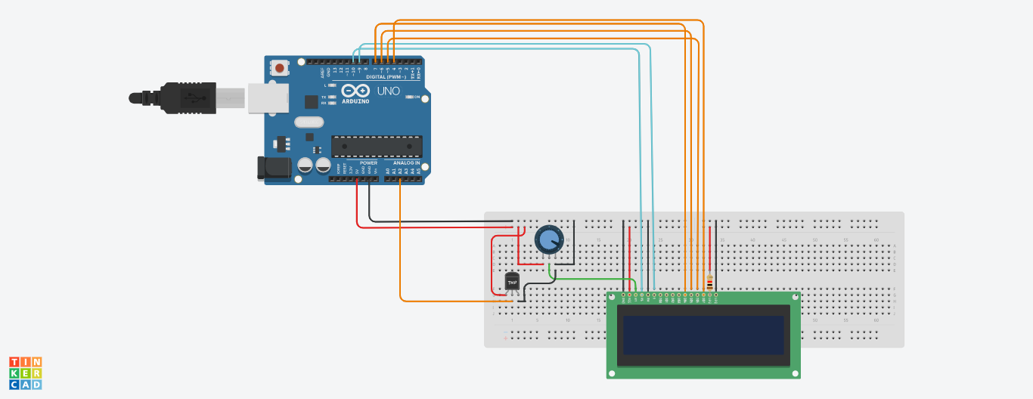

#include <LiquidCrystal.h>

LiquidCrystal lcd (10,9,7,6,5,4);

void setup ()

{

pinMode (A2, INPUT);

Serial.begin(9600);

lcd.begin(16,2);

}

void loop ()

{

int temperature = analogRead(A2);

Serial.println(temperature);

delay (3000);

lcd.print(temperature);

lcd.println("k");

}